Review: Advancements in 3D-Printed Epifluidic Electronic Skin for Machine Learning-Enabled Multimodal Health Monitoring (December 2023)

Laurence Jorissen

*Abstract*— In order to provide individualized health monitoring and intervention in digital health contexts, this study investigates the revolutionary potential of the epifluidic elastic electronic skin (e3-skin), integrating machine learning in a state-of-the-art wearable device. The e3-skin's creation, features, and applications are explained. The e3-skin combines microfluidics, energy storage, and a variety of sensors using SSE-based 3D printing to provide real-time sweat analysis and vital sign monitoring. The research highlights the e3-skin's versatility for health monitoring by going into detail about the material selection, ink formulation, and 3D printing procedures. Significant advancements are presented, such as high-precision sensors, microfluidic systems, biosensors for biomarker detection, and high-performance energy sources. Human assessments validate the e3-skin's capacity for machine learning-based behavioral analysis and continuous vital sign monitoring, establishing it as a comprehensive platform for customized healthcare.

# INTRODUCTION

The application of machine learning to an epifluidic elastic electronic skin (e3-skin) with a variety of physiochemical sensing capabilities becomes critical to maintaining a balanced lifestyle and early detection of symptoms, which is necessary to maintain physical health and prolong one's healthy lifespan. Essentially, the focus of this study is to present and clarify the development, capabilities, and possible applications of e3-skin as a cutting-edge wearable technology for customized health monitoring and intervention in the context of digital health [1].

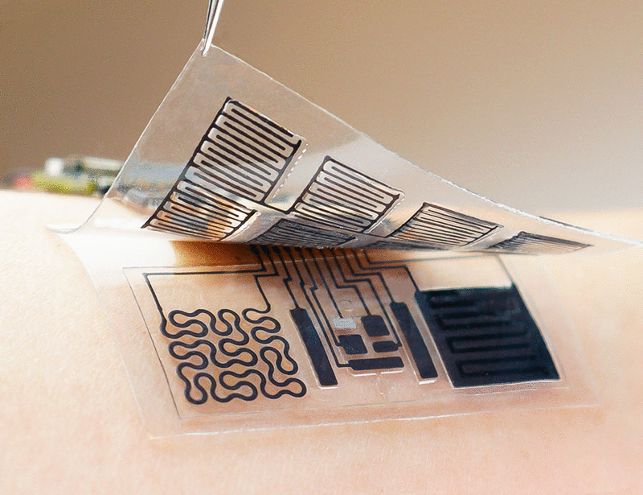

Fig. 1. e3-skin

## Development of the e3-skin

The development of the e3-skin represents a groundbreaking stride in wearable technology. Utilizing cutting-edge SSE-based 3D-printing, this technology integrates diverse sensors like electrochemical biosensors, biophysical sensors, and microfluidics into an elastic electronic skin. The e3-skin's innovative fabrication method, involving custom inks and selective phase elimination, creates a flexible yet precise architecture. It allows for real-time monitoring of vital signs, sweat analysis, and sustainable energy storage, paving the way for personalized health monitoring and intervention in the digital health era [1].

## Capabilities of the e3-skin

The e3-skin offers an array of impressive capabilities. It combines advanced sensors, such as electrochemical biosensors and biophysical sensors, with microfluidics and energy storage modules. This innovative system enables real-time monitoring of vital signs, comprehensive sweat analysis, and sustainable energy usage. The e3-skin's multifunctional design, coupled with its ability to collect diverse physiological data, holds significant promise for personalized healthcare applications in the digital health landscape [1].

## applications of the e3-skin

The e3-skin holds immense potential for diverse applications in healthcare. Its sophisticated sensor array, microfluidics, and sustainable energy storage capabilities enable real-time monitoring of vital signs, comprehensive sweat analysis, and prolonged data collection during daily activities. This technology opens doors to personalized healthcare solutions, including precise health monitoring, early symptom detection, and tailored interventions. Its versatility positions the e3-skin as a key player in the advancement of healthcare in the digital era [1].

This manuscript was submitted for review on the 1st of December 2023. L. J. Author is with the University of Hasselt, Hasselt, Limburg 3500 Belgium (e-mail: Laurence.jorissen @student.uhasselt.be).

# Materials and methods

This study's materials and techniques show a methodical and comprehensive approach to creating and testing the epifluidic elastic electronic skin (e3-skin). This all-inclusive methodology includes in vitro and on-body assessments, sensor creation, rigorous material characterization methods, and machine learning analysis. Together, these techniques make it possible to fabricate, evaluate, and use the e3-skin for individualized health monitoring [1].

## Materials

The research used a range of cutting-edge materials to develop specific sensors that are essential to the operation of the e3-skin. The previously mentioned materials were specifically selected to facilitate a range of sensor functionalities, including interconnects that form connections between electronic systems [4], biophysical sensors that quantify physical properties or bodily activities, biochemical sensors that identify biomarkers or analytes that are found in biological fluids [5], and electrodes where all of these are embedded in the e3-skin. Real-time physiological parameter monitoring was made possible by the careful selection of materials, demonstrating the multifunctionality of the e3-skin for health monitoring [1].

## Methods

The methods employed in this study encompassed a comprehensive approach involving diverse techniques for material preparation, ink formulation, and 3D printing processes. The research team developed specialized inks, such as MXene and MX-PB inks, as well as SBS and PDMS-based inks, tailored for specific sensor functionalities [1]. There has been a lot of interest in MXene because of its unique qualities. Fabricating an ink based on MXene has significant potential in the field of flexible electronics what would be of good usage for the e3-skin [2].

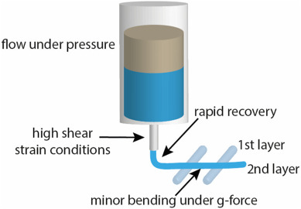

Fig. 2. Semi-solid extrusion (SSE) 3D printing

They utilized cutting-edge techniques like SSE-based 3D printing to construct microfluidics, biosensors, and microstructured conductive pathways. This methodological strategy enabled the creation of an intricate and functional e3-skin, capable of real-time monitoring through a combination of sensors and microfluidic modules [1]. Although SSE has potential, more research and development are necessary before this technology can be fully included into primary healthcare. In order to guarantee more individualized and successful therapies in clinical practice, such improvements are essential [3].

# Results

The study showcased impressive progress in several areas:

The e3-skin integrated biophysical sensors and interconnects, allowing for accurate temperature and pulse rate measurement, through high-precision printing using MXene ink. High sensitivity and stability were demonstrated by these sensors, which is essential for precise monitoring under mechanical stress [1].

The incorporation of electrochemical biosensors that are 3D printed has made it easier to identify biomarkers in perspiration, including alcohol, glucose, and uric acid. These biosensors showed remarkable sensitivity and selectivity, opening up a possible path for ongoing health monitoring using sweat analysis [1].

Furthermore, a pH sensor was created to gauge variations in sweat pH, improving the precision of the biochemical analysis of the e3-skin. To guarantee accurate enzymatic reactions in changing pH and temperature settings, real-time calibrations were carried out [1].

The research team created microfluidic systems that can be 3D printed and used to extract and sample biofluids, especially sweat [1]. These microfluidics systems make use of the small-scale chemical and physical characteristics of liquids and gases [6]. They enabled accurate and on-demand sweat sample for the embedded biochemical sensors' real-time analysis when combined with iontophoretic[1] sweat induction modules [1].

High-performance 3D-printed MXene-based micro-supercapacitors (MSCs) were created and combined with solar cells to provide a sustainable energy source. The exceptional energy density, mechanical stability, and capacitance retention exhibited by these MSCs allowed the e3-skin to operate independently without a battery tether [1].

The e3-skin's capacity to continually monitor vital signs and glucose levels in real time during a variety of activities was highlighted in evaluations by human subjects, offering insightful information about physiological reactions, such as those during exercise and post-meal states [1].

Added to that, the e3-skin's multimodal data was processed by machine learning algorithms to precisely anticipate behavioral reactions, including reaction times and impairments in inhibitory control brought on by alcohol use [1].

Overall, this ground-breaking study demonstrated the e3-skin as a full-featured platform for ongoing behavioral evaluation and health monitoring, with important implications for fitness tracking, behavioral analysis, and personalized healthcare [1].

References

1. Y. Song et al., "3D-printed epifluidic electronic skin for machine learning–powered multimodal health surveillance," *Science Advances*, vol. 9, no. 37, p. 13, Sep. 13, 2023. DOI: 10.1126/sciadv.adi6492.
2. B. Zazoum, A. Bachri, and J. Nayfeh, "Functional 2D MXene Inks for Wearable Electronics," Materials, vol. 14, no. 21, p. 6603, Nov. 2, 2021. DOI: 10.3390/ma14216603.
3. M. S. Algahtani, A. A. Mohammed, and J. Ahmad, "Extrusion-Based 3D Printing for Pharmaceuticals: Contemporary Research and Applications," Current Pharmaceutical Design, vol. 24, no. 42, pp. 4991-5008, 2018. DOI: 10.2174/1381612825666190110155931. Publisher: Bentham Science Publishers.
4. Wikipedia contributors, "Interconnect (integrated circuits)," Wikipedia, The Free Encyclopedia. Available: https://en.wikipedia.org/wiki/Interconnect_(integrated_circuits). [Accessed: November, 28, 2023].
5. M. A. Yokus and M. A. Daniele, "Integrated non-invasive biochemical and biophysical sensing systems for health and performance monitoring: A systems perspective," Biosensors and Bioelectronics, vol. 184, Jul. 15, 2021,Art. no. 113249. Available: https://doi.org/10.1016/j.bios.2021.113249
6. "Microfluidics: A general overview of microfluidics," Elveflow. [Online]. Available: https://www.elveflow.com/microfluidic-reviews/general-microfluidics/a-general-overview-of-microfluidics/. Accessed on: November 28, 2023.
7. National Institutes of HealthNational Library of Medicine. (2023). Iontophoresis. MedlinePlus. [Online]. Available: https://medlineplus.gov/ency/article/007296.htm. Accessed on: November 30, 2023.

1. Iontophoretic is the technique of putting a little amount of electrical current through the skin.[7]